Draft Program CTLS conference 2018
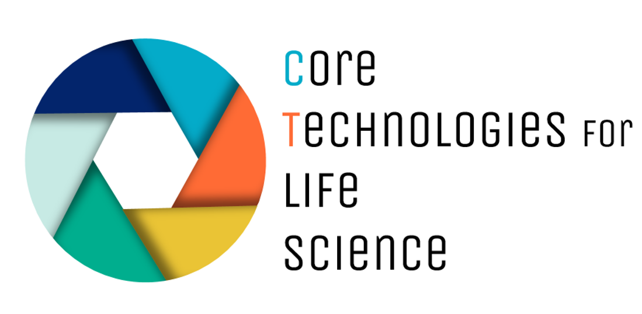

Day 1 Sunday
15:00-16:45 Registration and company workshops or pre-meeting satellite sessions
16:45-17:00 Welcome, Overview of the conference and housekeeping Issues
17:00-18:00 Keynote: Sir Paul Nurse, the importance of CFs in the Crick Institute
18:30-19:30 Belgian Beer tasting in a local Ghent café
19:30-22:00 Dinner with Keynotes and CTLS board/VIB management (by invitation)

Day 2 Monday
09.00 - 09:30 Registration and welcome coffee
09:30 - 12.05 Plenary Session 1 (including 30 min coffee break) Big Data Sarah Butcher and Alex Botzki
12.05 - 13.00 Lunch
13.00 - 14.00 Company workshops 1
14:15 - 16:55 Parallel sessions
Track 1 Emerging model systems and samples. Marion Berard and Valentina Adami
Track 2 Multi scale/Multi disciplinary Mesoscopic methods. Spenser Shorte and Ralf Palmisano
Track 3 Research and Development in CFs. Chris Guérin and Julia Fernandez-Rodriquez
Track 4 Data management in CF’s. Ljudmila Borisenko and Geert Van Minnebruggen
17:00 - 18:30 Poster session & Reception
18:30 – 20:00 CTLS EC meeting
20:00 - 23:00 EC and OC dinner (by invitation)
Day 3 Tuesday

08:30 - 09:00 Registration
09:00 - 10:00 Keynote: Frances Weis-Garcia, past president, ABRF
10:00 – 12:35 Plenary Session 2 International alliances, networks and cooperation (including 30 min coffee break) Patrick England and Monica Morales Ballus
12:35 - 13:15 Lunch
13:15 - 14:15 Company workshops 2
14:15 – 16:55 Parallel sessions (including 30 min coffee break)
Track 5: Single cell technologies. Stefaan Derveaux and Sascha Sauer
Track 6: QC Rigor and reproducibility. Achim Treumann and Francis Impens
Track 7: Career path for CF staff. Nadine Utz and Saskia Lippens
Track 8: Integrating CF infrastructures creating value. Mery Pina and Cath Brooksbank
17:00 - 18:00 CTLS AGM
18:15 - 19:15 Boat tour of Ghent waterways
19:30 - 22:30 Conference dinner, restaurant “Oude Vismijn”
Day 4 Wednesday
09:30 - 10:15 Keynote: Kurt Vandenberghe, Director Policy Development and Coordination, European Commission
10:15-12:50 Plenary Session 3 (including 30 min coffee break) Contracts, Agreements and Expectations: CF interactions with government, clients, institutions and each other. Marc Bickle and Josh Rappoport
12:50 - 13:00 Wrap up and farewell
13:00 - 18:00 Satellite meetings (optional TBA)

Confirmed speakers in green

